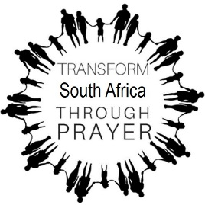

**SA PRAYER CIRCLES**

*As in Heaven, so in this city!*

**What is SA Prayer Circles?**

SA Prayer Circles is a multi-church prayer movement that aims to transform South Africa through prayer.

**Our Vision**

The vision is based on the Lord’s Prayer that instructs us how to pray: Mathew 6: 10: *Your kingdom come, your will be done, on Earth as it is in heaven*. We want to see God’s will established in our cities! Through dedicated prayer, every city in South Africa can indeed transform to be a city of light, a safe and beautiful place where we all live together in peace and harmony.

**Our Mission**

Our strategy is to establish a Prayer Circle Movement in **every city** of South Africa. Prayer Circles are established in **parks** because parks are ‘neutral’ ground – it does not belong to anyone and therefore helps to **unify believers** from different churches. We strive to establish a Prayer Circle in **every suburb** of your city.

**How does it work?**

We plant a cross inscribed with the words *As in Heaven, so in this city* in the park where believers convene to pray. Believers get together every Monday 17h30 wintertime and 18h00 summertime in the various parks to pray for the city.

**Join a Prayer Circle!**

To join a Prayer Circle, WhatsApp your **name and suburb** to the Prayer Circle Coordinator in your city:

Coordinator name:

Contact number:

**Ephesians 6:12:** *For our struggle is not against flesh and blood, but against the rulers, against the authorities, against the powers of this dark world and against the spiritual forces of evil in the heavenly realms.*

Let us take back our cities for Jesus!